THE CHILDREN OF LIR: AN IRISH LEGEND
King Lir of Ireland had four young children who were cared for tenderly at first by their stepmother, the new queen; but there came a time when she grew jealous of the love their father had for them, and resolved that she would stand for it no longer. Sometimes there was murder in her heart, but she could not bear the thought of that wickedness, and she resolved at last to choose another way to rid herself of them.
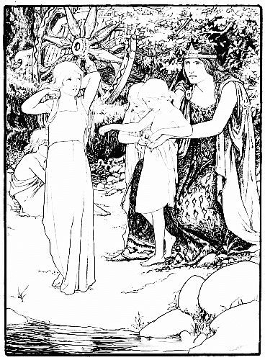
One day she took them to drive in her chariot:—Finola, who was eight years old, with her three younger brothers,—Aodh, Fiacre, and little Conn, still a baby. They were beautiful children, the legend says, with skins as white and soft as swans’ feathers, and with large blue eyes and very sweet voices. Reaching a lake, she told them that they might bathe in the clear water; but so soon as they were in it she struck them with a fairy wand,—for she was of the race of the Druids, who had magical power,—and she turned them into four beautiful snow-white swans. But they still had human voices, and Finola said to her,
“This wicked deed of yours shall be punished, for the doom that awaits you will surely be worse than ours.” Then Finola asked, “How long shall we be in the shape of swans?”
“For three hundred years,” said the woman, “on smooth Lake Darvra; then three hundred years on the sea of Moyle” (this being the sea between Ireland and Scotland); “and then three hundred years at Inis Glora, in the Great Western Sea” (this was a rocky island in the Atlantic). “Until St. Patrick shall come to Ireland and bring the Christian faith, and until you hear the Christian bell, you shall not be freed. Neither your power nor mine can now bring you back to human shape; but you shall keep your human reason and your Gaelic speech, and you shall sing music so sweet that all who hear it shall gladly listen.”
She left them, and before long their father, King Lir, came to the shore and heard their singing. He asked how they came to have human voices. “We are your four children,” said Finola, “changed into swans by our stepmother’s jealousy.” “Then come and live with me,” said her sorrowing father. “We are not permitted to leave the lake,” she said, “or live with our people any more. But we are allowed to live together and to keep our reason and our speech, and to sing sweet music to you.” Then they sang, and the king and all his followers were at first amazed and then lulled to sleep.
Then King Lir returned and met the cruel stepmother at her father’s palace. When her father, King Bove, was told what she had done, he was hot with anger. “This wicked deed,” he said, “shall bring severer punishment on you than on the innocent children, for their suffering shall end, but yours never shall.” Then King Bove asked her what form of existence would be most terrible to her. She replied, “That of a demon of the air.” “Be it so,” said her father, who had also Druidical power. He struck her with his wand, and she became a bat, and flew away with a scream, and the legend says, “She is still a demon of the air and shall be a demon of the air until the end of time.”
After this, the people of all the races that were in Erin used to come and camp by the lake and listen to the swans. The happy were made happier by the song, and those who were in grief or illness or pain forgot their sorrows and were lulled to a peaceful calmness. There was peace in all that region, while war and chaos filled other lands. Huge changes took place in three centuries—towers and castles rose and fell, villages were built and destroyed, generations were born and died;—and still the swan-children lived and sang, until at the end of three hundred years they flew away, as was decreed, to the stormy sea of Moyle; and from that time it was made a law that no one should kill a swan in Ireland.
Beside the sea of Moyle they found no longer the peaceful and wooded shores they had known, but only steep and rocky coasts and a wild, wild sea. There came a great storm one night, and the swans knew that they could not keep together, so they resolved that if separated they would meet at a rock called Carricknarone. Finola reached there first, and took her brothers under her wings, all wet, shivering, and exhausted. Many such nights followed, and in one terrible winter storm, when they nestled together on Carricknarone, the water froze into solid ice around them, and their feet and wings were so frozen to the rock that when they moved they left the skin of their feet, the quills of their wings, and the feathers of their breasts clinging there. When the ice melted, and they swam out into the sea, their bodies smarted with pain until the feathers grew once more.
One day they saw a glittering troop of horsemen approaching along the shore and knew that they were their own kind, though from far generations back, the Dedannen. They greeted each other with joy, for the Dedannan had been sent to seek for the swans; and on returning to their chiefs they told what had passed, and the chiefs said, “We cannot help them, but we are glad they are living; and we know that at last the enchantment will be broken and that they will be freed from their sorrows.” So passed their lives until Finola sang, one day, “The Second Woe has passed—the second period of three hundred years,” when they flew out on the broad ocean, as was decreed, and went to the island of Inis Glora. There they spent the next three hundred years, amid yet wilder storms and yet colder winds. No more the peaceful shepherds and living neighbors were around them; but often the sailor and fisherman, in his little boat, saw the white gleam of their wings or heard the sweet notes of their song and knew that the children of Lir were near.
But the time came when the nine hundred years of banishment were ended, and they might fly back to their father’s old home, Finnahà. Flying for days above the sea, they landed at the palace once so well known, but everything was changed by time—even the walls of their father’s palace were crumbled and rain-washed. So sad was the sight that they remained one day only, and flew back to Inis Glora, thinking that if they must be forever alone, they would live where they had lived last, not where they had been reared.
One May morning, as the children of Lir floated in the air around the island of Inis Glora, they heard a faint bell sounding across the eastern sea. The mist lifted, and they saw afar off, beyond the waves, a vision of a stately white-robed priest, with attendants around him on the Irish shore. They knew that it must be St. Patrick, who was bringing, as had been so long foretold, Christianity to Ireland. Sailing through the air, above the blue sea, towards their native coast, they heard the bell once more, now near and distinct, and they knew that all evil spirits were fleeing away, and that their own hopes were to be fulfilled.
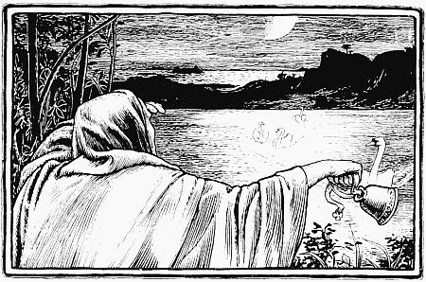
As they approached the land, St. Patrick stretched his hand and said, “Children of Lir, you may tread your native land again.” And the sweet swan-sister, Finola, said, “If we tread our native land, it can only be to die, after our life of nine centuries. Baptize us while we are yet living.” When they touched the shore, the weight of all those centuries fell upon them; they resumed their human bodies, but they appeared old and pale and wrinkled. Then St. Patrick baptized them, and they died; but, even as he did so, a change swiftly came over them; and they lay side by side, once more children, in their white night-clothes, as when their father Lir, long centuries ago, had kissed them at evening and seen their blue eyes close in sleep and had touched with gentle hand their white foreheads and their golden hair. Their time of sorrow was ended and their last swan-song was sung; but the cruel stepmother seems yet to survive in her bat-like shape, and a single glance at her weird and malicious little face will lead us to doubt whether she has yet fully atoned for her sin.
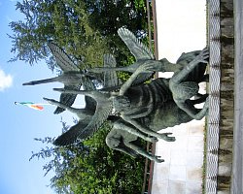 The Children of Lir’s statue in Dublin’s Garden of Remembrance

http://www.youtube.com/watch?v=ingfxd6sJ2Y

The Children of Lir Activities
1. Look at the underlined words in the story. In pairs, match the words with their definitions:
Doom | a)To soothe or make quiet
Sorrow/Grief | b) Collapse
Lull | c) To step or walk
Quills | d)Fate, destiny
Gleam | e) One of the large feathers of the wing or tail of a bird
Crumble | f) distress caused by lost, disappointment
Mist | g) to make up errors
Tread | h) a flash or beam of light
Atoned | i) a mass of tiny drops resembling fog

2. Answer the following questions:
1. What was the name of Lir’s daughter?
2. Who did Lir marry after the children’s mother died?
3. Why was she jealous of the children?
4. What did she do to the children?
5. How long did the children have to be swams?
6. What places did they have to go?
7. What happened to their stepmother?
8. Who put a spell on her? Why could he do it?
9. How did the children become human again?
10. Why do you think this story is a legend? Mention and explain two reasons.
3. Order the following story events in chronological order:
…….. Sawns in the Sea of Moyle …….. Swans in the Island of Inis Glora
…….. Lir and Oifa marry ………. St. Patrick baptizes the children
……. Swans revert to human form ………… Swans at the Lake of Darvra
…….. Oifa turned into air demon …………. Children turned into swans
……. Swans return home
4. The Children of Lir is a sad Irish legend. Look at the characters below and say why they are sad:
King Lir ……………………………………………………………………………………………………………………………………………………………………………………………………………………………………………………………………………..
Oifa
………………………………………………………………………………………………………………………………………………………………………………………………………………………………………………………………………………
The Children of Lir
………………………………………………………………………………………………………………………………………………………………………………………………………………………………………………………………………………
5. Summarizing the Story. Find the missing words in the text.
drowned | bat | jealous | sprinkled | spell | feathers | grave | cackled

Long ago there lived a king called Lir. He lived with his wife and four children: Fionnuala, Aodh, Fiachra and Conn. They lived in a castle in the middle of a forest. When Lir’s wife died they were all very sad. After a few years Lir got married again. He married a ___________________ woman called Aoife.
Aoife thought that Lir loved his children more than he loved her. Oifa hated the children. Soon she thought of a plan to get rid of the children.

One summer’s day Oifa took the children to swim in a lake near the castle. The children were really happy to be playing in the water. Suddenly Oifa took out a magic wand. There was a flash of light and the children were nowhere to be seen. All there was to be seen was four beautiful swans, with their _____________________ as white as snow.

Oifa said, “I have put you under a ________________. You will be swans for nine hundred years,” she_________________. “You will spend three hundred years in Lough Derravaragh, three hundred years in the Sea of Moyle and three hundred years in the waters of Inish Glora,” Aoife said. She also said, “You will remain swans for nine hundred years until you hear the ring of a Christian bell.”

She went back to the castle and told Lir that his children had ________________. Lir was so sad he started crying. He rushed down to the lake and saw no children. He saw only four beautiful swans.

One of them spoke to him. It was Fionnuala who spoke to him. She told him what Oifa had done to them. Lir got very angry and turned Aoife into an ugly ________________. When Lir died the children were very sad. When the time came they moved to the Sea of Moyle.

Soon the time came for their final journey. When they reached Inish Glora they were very tired. Early one morning they heard the sound of a Christian bell. They were so happy that they were human again. The monk (some even say it was St. Patrick himself) ________________ holy water on them and then Fionnuala put her arms around her brothers and then the four of them fell on the ground. The monk buried them in one _________________. That night he dreamed he saw four swans flying up through the clouds. He knew the children of Lir were with their mother and father.

